MKNHS Plant Group visit to Blue Lagoon Local Nature Reserve 26 July 2026
Co-leaders: Charles Kessler and Richard Schmidt
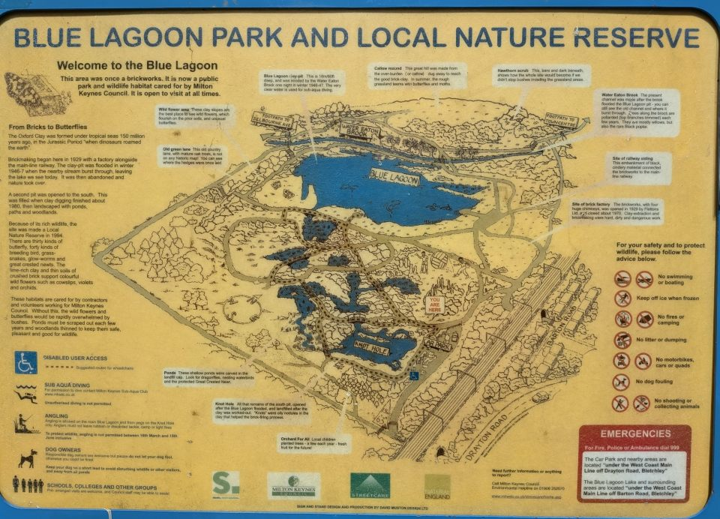
Background
Blue Lagoon is a Local Nature Reserve owned and managed by Milton Keynes City Council. The site used to be a brickworks, started by Flettons Ltd in 1929. Prior to that it was agricultural land. The main feature of the site is the Blue Lagoon lake. This was the main pit for extraction of clay for brick-making and is very deep and steep-sided. In spring 1947, snow lay on frozen ground following a hard winter. Sudden, very heavy rainfall, unable to penetrate the frozen ground, together with melting snow caused the brook running past the site to overflow and flood the pit, rendering it useless for further clay extraction. Knot Hole is a smaller lake on the site that was used for clay extraction after Blue Lagoon was flooded but which is now also water-filled. Brick-making at the site ceased in 1970 when the four tall chimneys of the kilns were demolished. The site was made a Local Nature Reserve in 1994, with some landscaping and planting undertaken.

Our visit
From the car park we set off around Knot Hole in an anti-clockwise direction. We then made our way to Blue Lagoon around which we also made an anti-clockwise circuit and then returned to our start at the car park.
In the vicinity of the car park we observed a number of plant species characteristic of disturbed ground, such as Coltsfoot, Bristly Oxtongue and Sowthistle. We were also fortunate to be able to observe growing close to each other three species of Alder: our native Common Alder, with its rounded leaves, Grey Alder which has pointed leaves and Italian Alder with heart-shaped leaves. This was a good opportunity to compare the three species at close quarters. It is likely that they were planted, although Common Alder, which is a pioneer species of wet ground, is likely to regenerate naturally from seed.
The first thing we noted about Knot Hole was the fringe of Common Reed, with its freshly-emerged, purplish inflorescence. A little bit further on we saw Lesser Reedmace, notable for the gap between male and female parts of the inflorescence; although the male parts had dried and been blown away the ‘gap’ was clear by its green colour. We were later to observe Common Reedmace, which has wider leaves, a thicker female inflorescence and no gap between male and female parts of the inflorescence. Also in Knot Hole was the submerged Rigid Hornwort with its finely-divided, feather-like whorls of leaves.
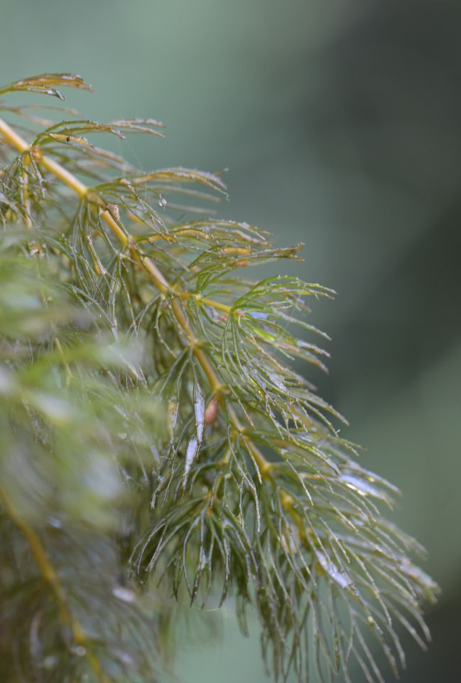
Rigid Hornwort (Photo © Bob Phillips)
As we made our way across towards Blue Lagoon we passed through very dense Hawthorn scrub. This is typical of land in this area that is left to revert to nature; last year, we saw a very similar scrub development on the callow mound at nearby Newton Leys and also at the rewilded arable fields at Strawberry Hill in Bedfordshire.
Blue Lagoon itself also was fringed by Lesser Reedmace, with splashes of colour from Purple Loosestrife and Fleabane. At the far north-west corner of Blue Lagoon we found a large Elm, much the largest in the vicinity and bigger than the size at which Elms usually succumb to Dutch Elm Disease. The tree was supporting very substantial growth of Ivy, which the managers of the reserve would be advised to cut. With its nectar-rich flowers, fleshy fruits and general provision of cover, Ivy is of course good for wildlife; however, in this case its weight and extensive canopy acting as a sail in strong wind risk pulling the Elm down, which would result in the loss of both plants. And there is plenty more Ivy on the surrounding trees that are less valuable and less vulnerable.
Beyond the Elm, there is a small hill, part of which was formed from topsoil removed to provide access to the clay for brick-making beneath and part of which formed an embankment for a link between the West Coast Main Line and the Oxford line. Here was a grassy habitat with an abundance of flowers, including Ox-eye Daisy, Agrimony, Common Knapweed and two species of Ragwort.
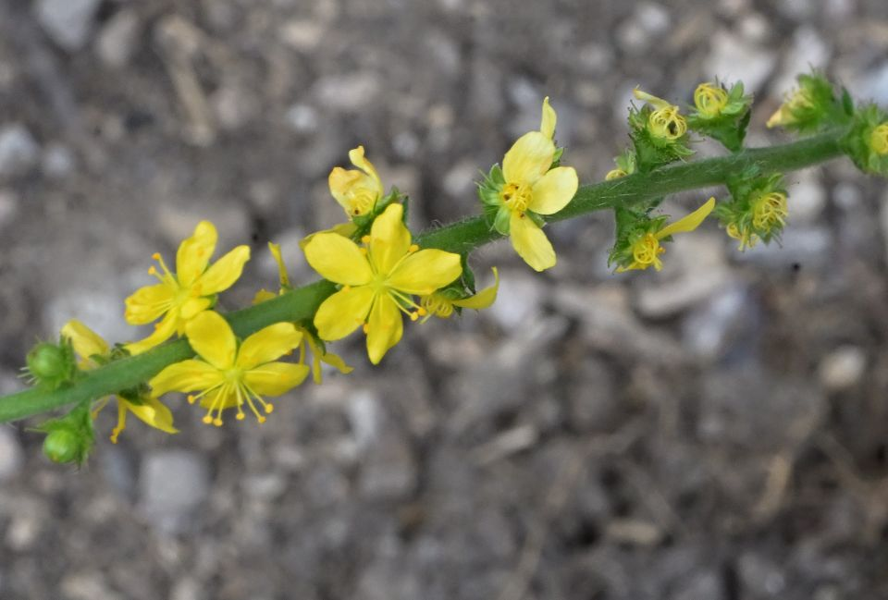
Agrimony (Photo © Bob Phillips)
At the east side of the lake, where the brick kilns were located, there was a very dry, rubbly area with plant life including Perforate St John’s Wort, Weld and Common Restharrow.
Around the site in general, we noted the extensive, recent work that had been undertaken to renovate paths and bridges, and particularly to cut back woody vegetation to provide more light and hopefully produce a better habitat for ground flora and invertebrates.
We also met some of the “Keeping the Blue Lagoon Beautiful” team. One of their activities is litter collection, unfortunately much needed at this site. They were very enthusiastic to know more about the wildlife of the area.
Invertebrates
Although the focus of interest for this visit was plants, many invertebrates were seen and the site is well-known for dragonflies. Amongst species observed were Common Blue, Gatekeeper, Meadow Brown and Red Admiral butterflies, Common Blue damselfly and Brown, Emperor and Migrant Hawker dragonflies. We also saw Buff-tipped moth larvae feeding on Grey Willow. (Thanks to Janice Robertson for her identification of these.)
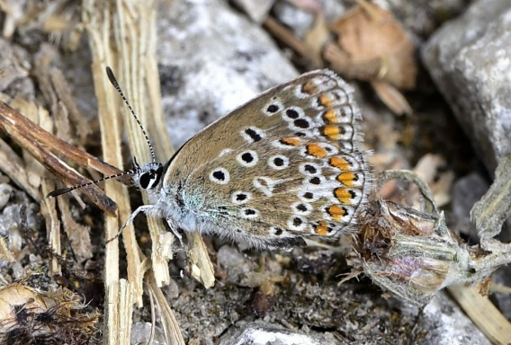 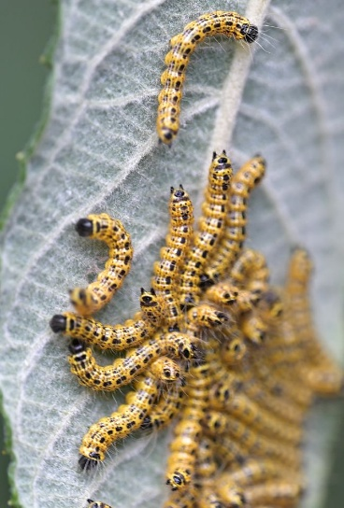
Common Blue butterfly (left); Buff-tip moth caterpillars on Grey Willow
(Photos © Bob Phillips)
In conclusion, this site contains a range of habitats and harbours much biodiversity as indicated by our list of plants observed. All this has been achieved in the space of 100 years, passing from agricultural land, through industrial site to today’s nature reserve.
Overall, we had an interesting morning in which 9 members of the Plant Group participated. A future visit earlier in the year to see a different range of plants in flower would be recommended.

Charles Kessler 2 August 2026

Annexes
Plant list (kindly prepared by Janice Robertson)
Photographs of plants taken during the visit (kindly provided by Bob Phillips)
including Notes on selected photographs

