A Chilly (but Brilliant) Botanical Wander Around Linford Wood – 10 May 2026
Sunday mornings in May are supposed to feel like spring but not this one. Linford Wood greeted us with a proper nip in the air (bobble hats were very much needed), but thankfully the rain kept itself to itself.
A group of 15 of us set off for a guided botanical stroll—one of those outings where you don’t exactly get your heart rate up, but you do end up noticing a whole world of detail under your feet.
The aim was simple (and wonderfully nerdy): to spot Ancient Woodland Indicator (AWI) plants and chat about what they can tell us—how long a woodland has been around, and how it’s been managed over the years. The main goal was to find the ultimate AWI Herb Paris and this mission was accomplished and more!
Even with frozen fingers, it turned into a cracking walk. We clocked up 90+ plant species, and the sharper eyes in the group helped confirm five tricky ones—plus we added 14 more compared with the previous week’s recce. Proof that a second look (and a few extra botanists) always pays off. Linford Wood boasts at least 17 distinct Ancient Woodland Indicator species across the categories for the southern region with clay soils.
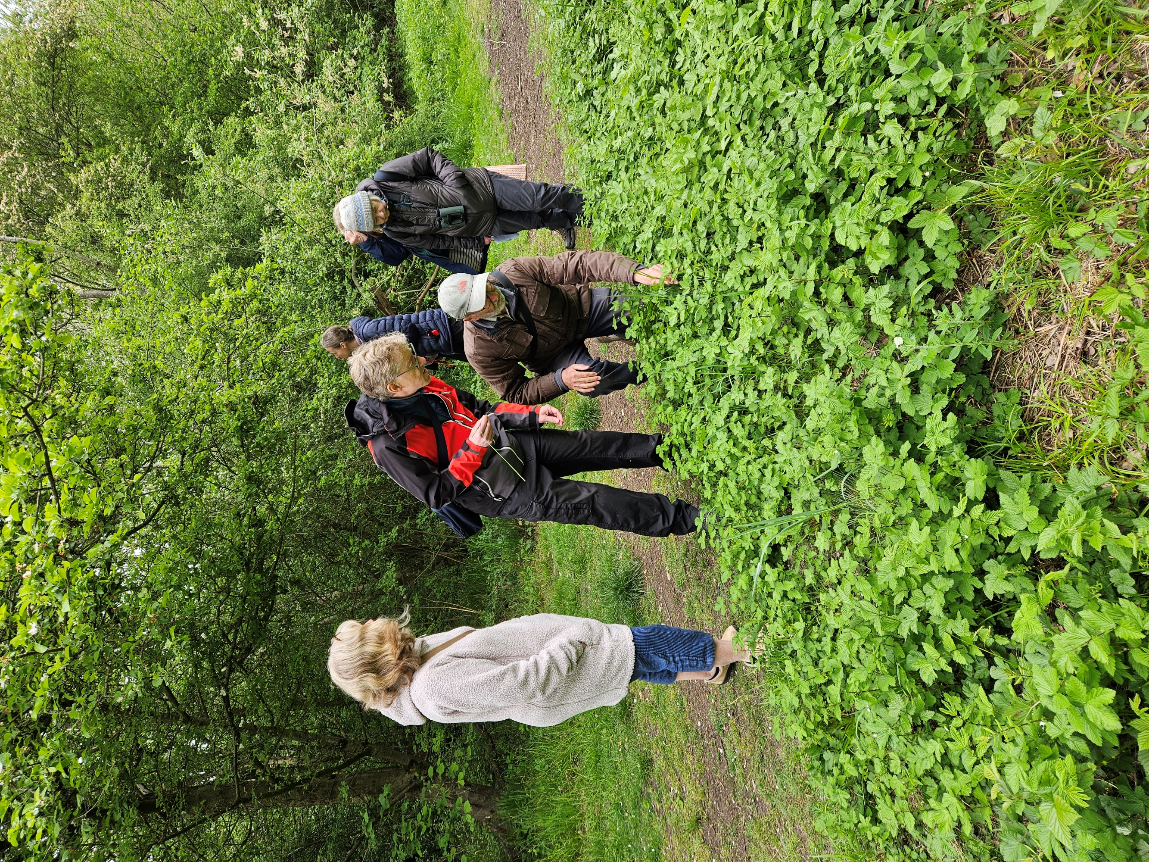
And the best bit? You don’t even have to wander far from the car park before you start bumping into the good stuff—those classic ancient-woodland tells.
We spotted spindle and several wild service trees around the car park, in addition to the replanting at the southern end of the wood. They’re often listed as an ancient woodland indicator—but it really only counts as one when the trees are naturally occurring, rather than planted.
So… what makes a plant an “Ancient Woodland Indicator”?
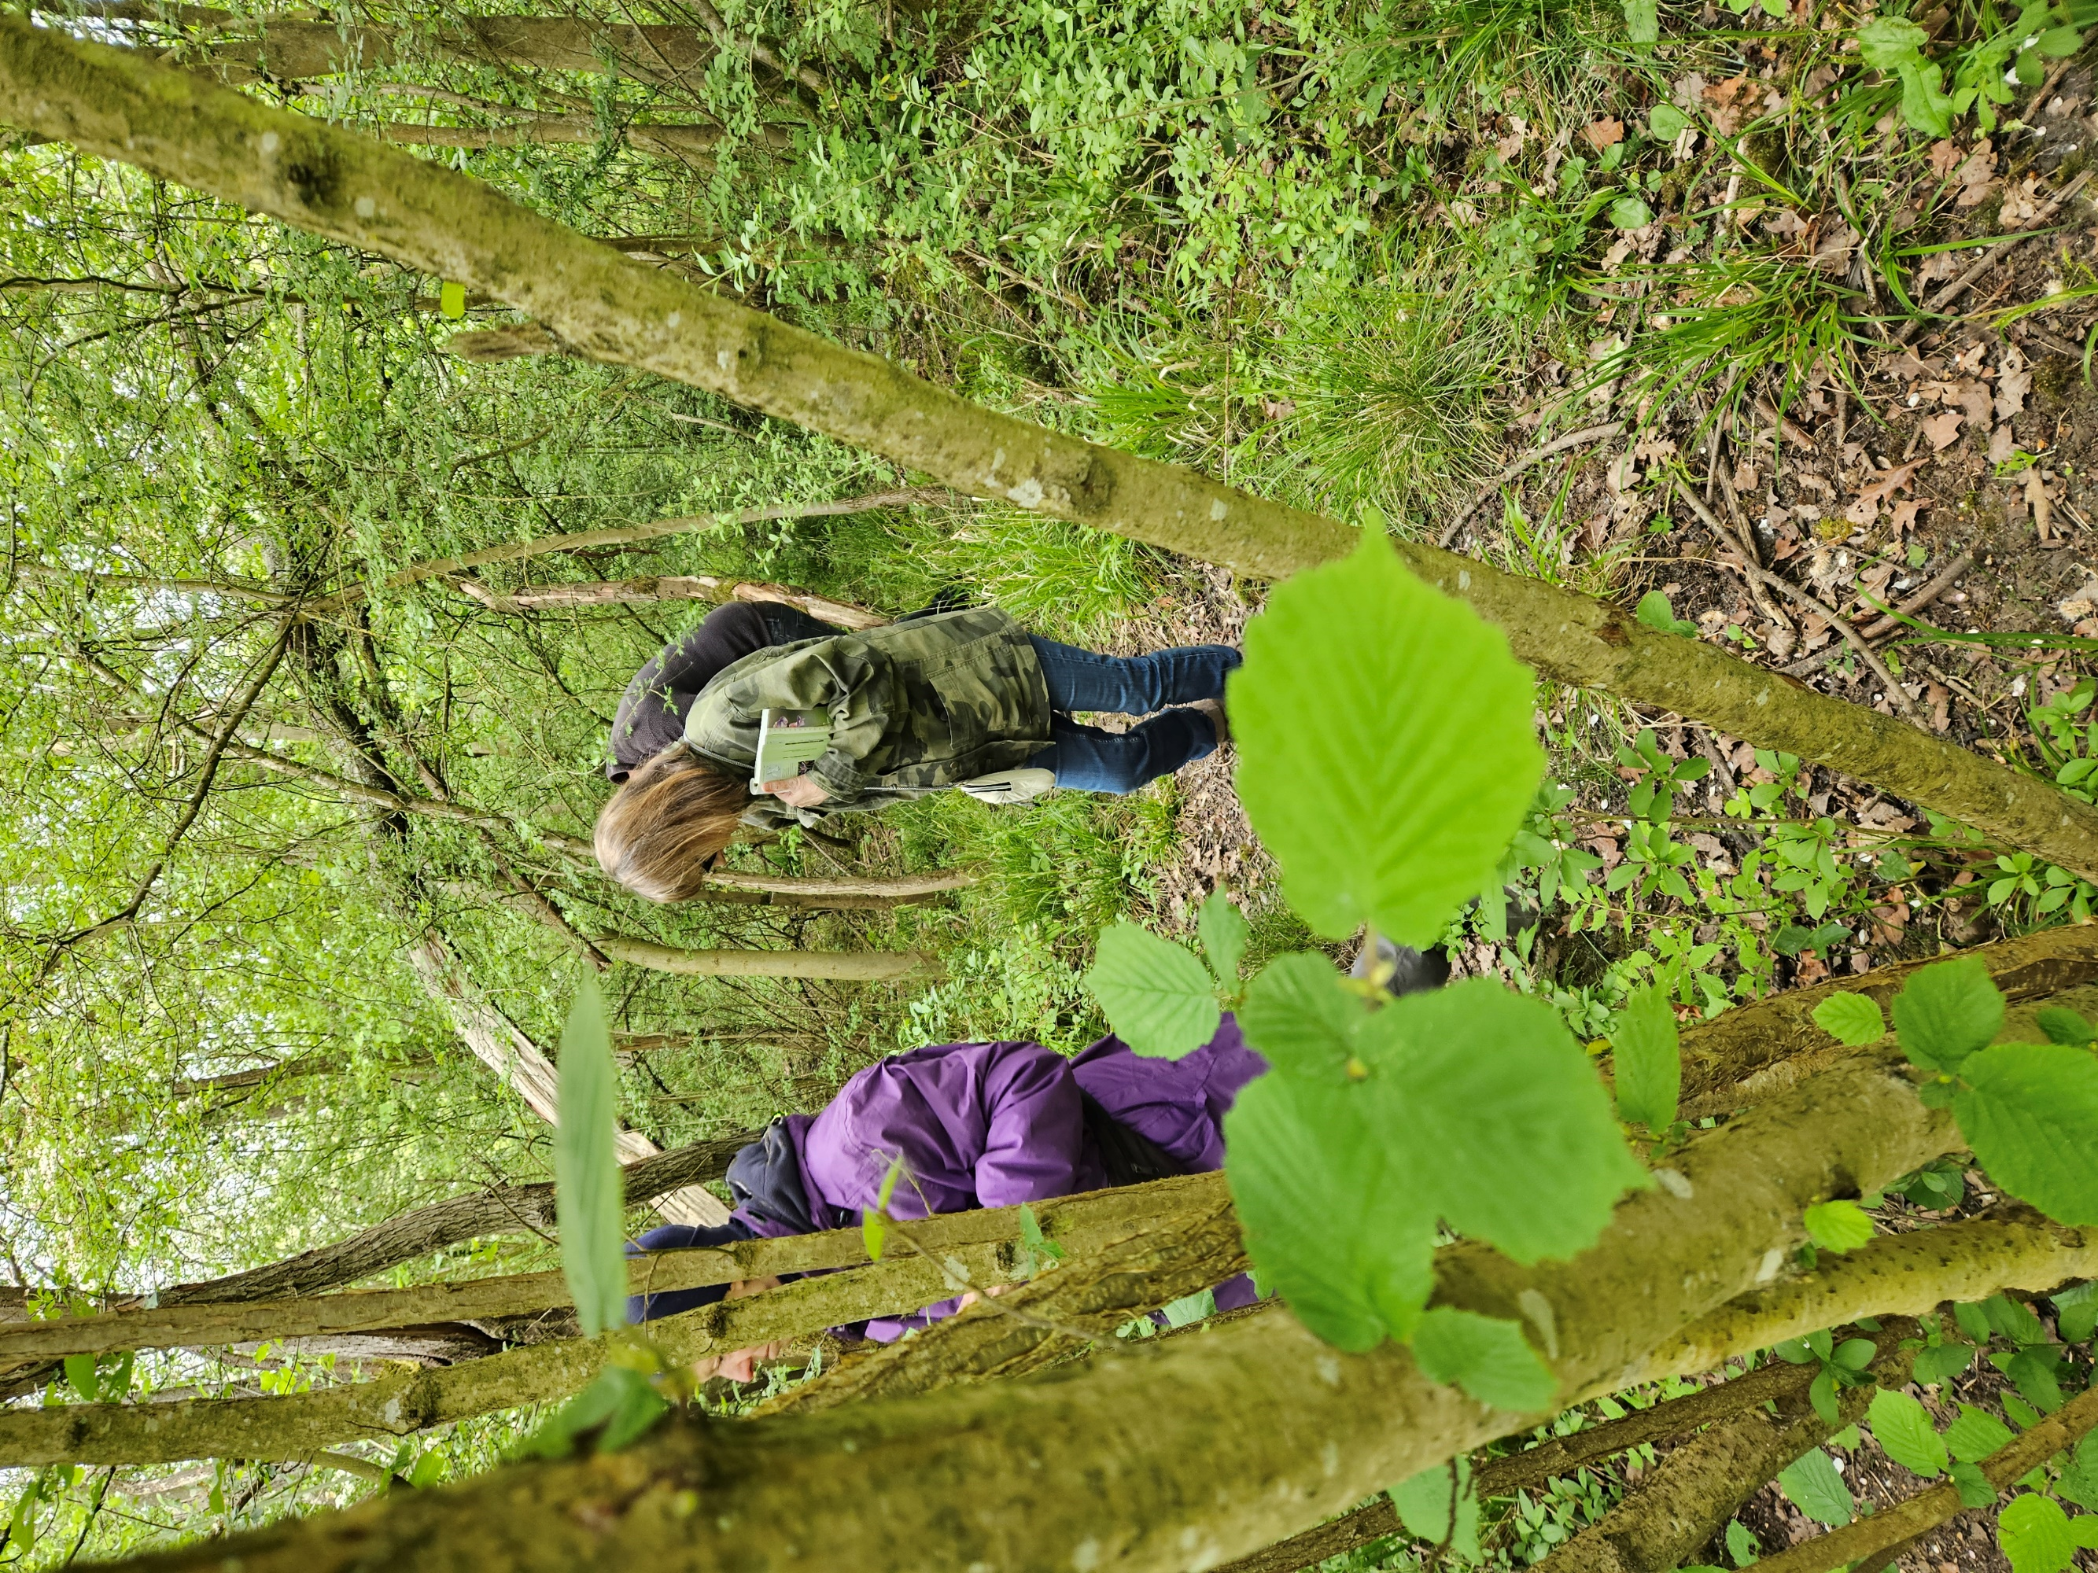
Not every woodland plant is a reliable little time capsule. The best indicators tend to share a few handy traits:
- Poor dispersal mechanisms (so they don’t travel far or fast)
- Not very competitive (they get crowded out easily)
- Sensitive to disturbance (ploughing, heavy trampling, big changes)
- Slow growth cycles (they take their time establishing)
One we didn’t manage to pin down on the day was Midland hawthorn. Roy Maycock’s historical records show it’s here, but it didn’t show itself during the recce or the event—so consider that a mini side-quest for your next visit. Although check the photo annex to decide for yourself.
We also missed goldilocks buttercup and moschatel (aka “Town Hall Clock”) this time around—both have been recorded here before, just not on this particular outing. These plants are also strong Ancient Woodland Indicators as they are rarely found anywhere except in ancient woods. We thank Martin Kincaid for these two AWIs to search for. If you’re into a longer walk around the wood, follow the dotted line south of the wood to the start on the route map (web editor to link to the downloadable pdf walk map)*remove from upload*
We kept to a short loop route (plant walks cover hilariously little ground, because you stop every ten steps), using the previous week’s recce list as a bit of a treasure map. If you fancy stretching your legs next spring, there’s the option of a longer circuit—especially if you’ve never met pignut, goldilocks buttercup or twayblade in the wild.
Hot drinks, sharp eyes, and good company
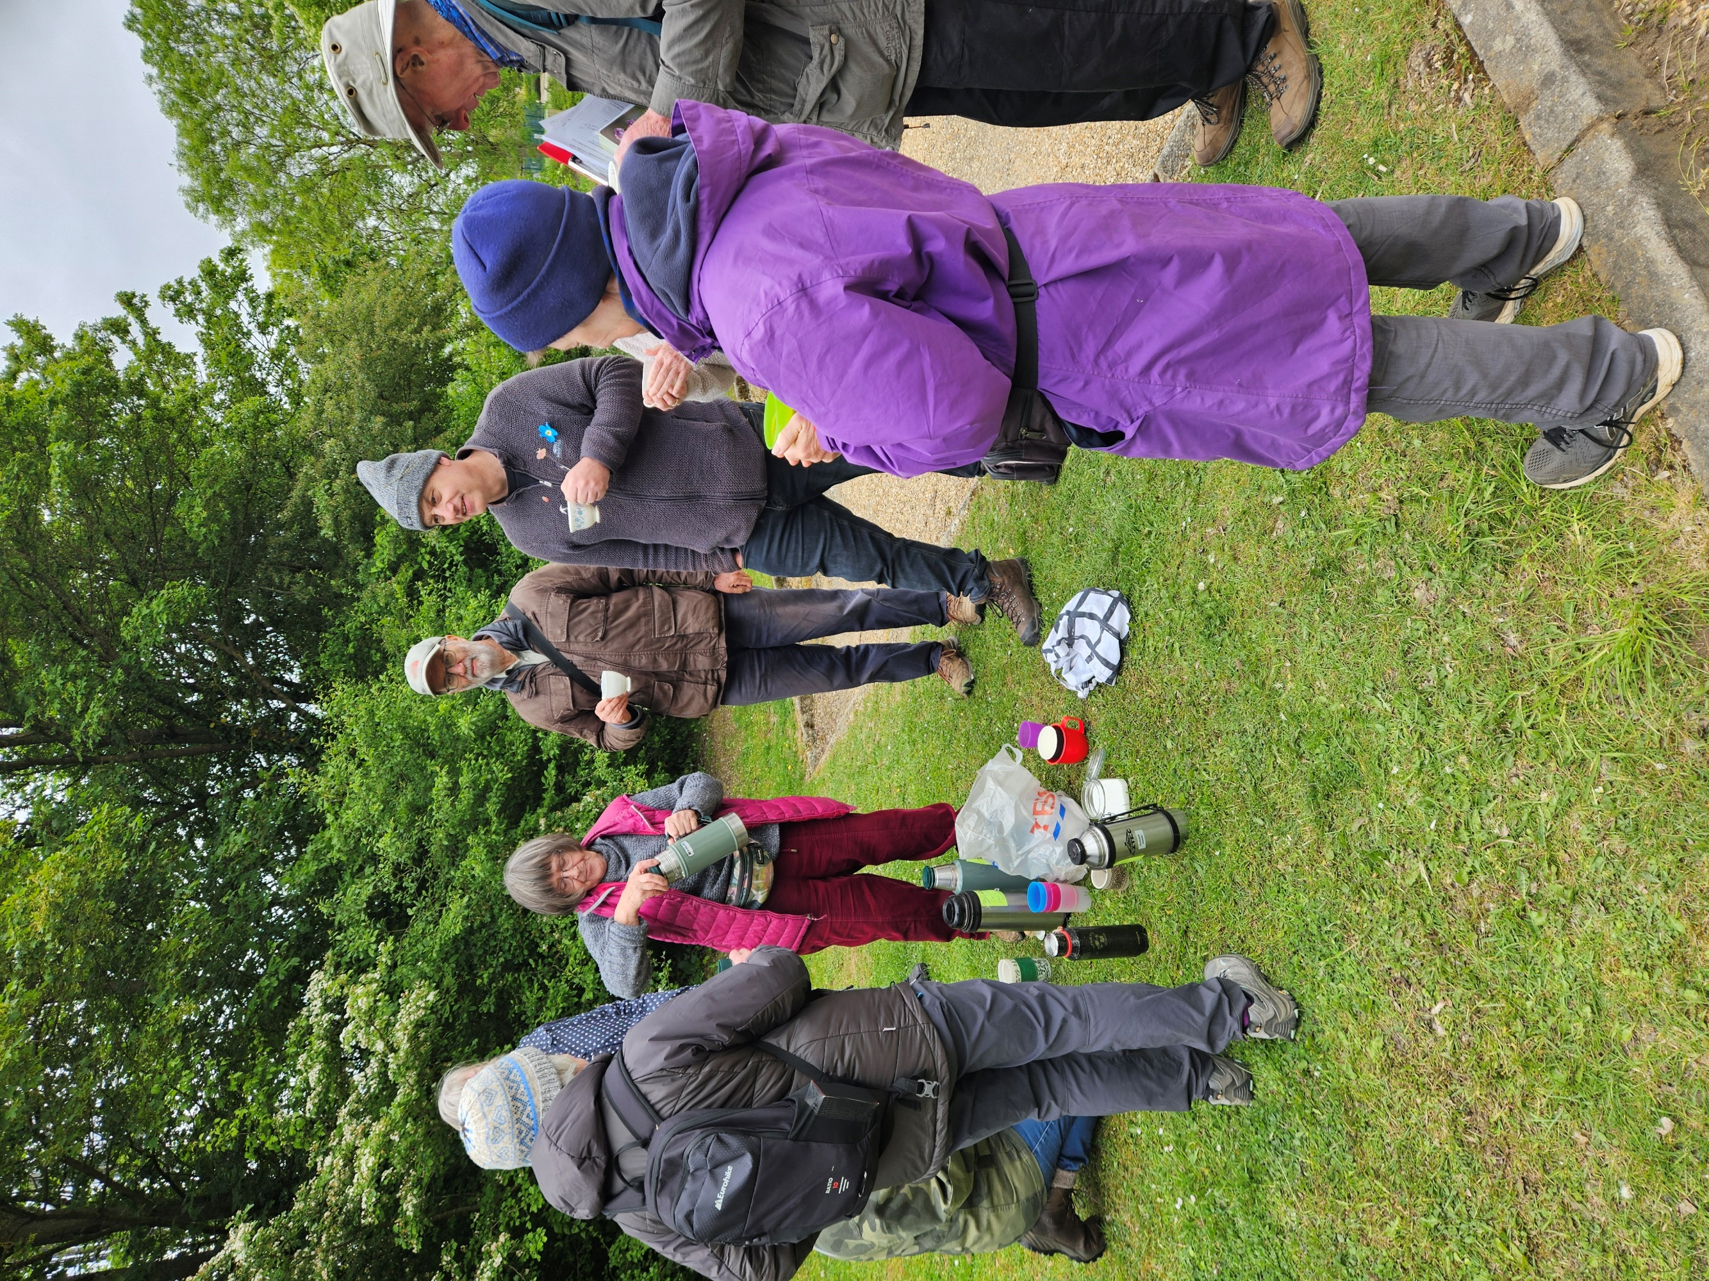
Huge thanks to Jenny Mercer for arriving with much-needed hot refreshments—genuinely the sort of thing that restores feeling to your fingers and warms the soul.
And a big shout-out to Joan Hughes for her first outing as field lister—brilliantly supported by Janice Robertson and Charles Kessler, who helped confirm some of the fiddlier groups (speedwells, ferns, and grasses… you know who you are!).
Photos were a team effort too, especially with our resident photographer away on holiday.
A quick bit of Linford Wood backstory
Linford Wood has been wooded for at least 700 years, which makes it officially Ancient Woodland—exactly the sort of place you’d expect to find those slow-to-move, slow-to-change indicator plants.
If you like the technical labels, it’s recorded in National Vegetation Classification terms as W8 Fraxinus excelsior–Acer campestre–Mercurialis perennis woodland—a lowland, mixed deciduous community on base-rich soils, and a great match for many of the species we were hoping to spot.
For centuries it formed part of the Great Linford Manor Estate. Way back in 1284 it was enclosed as a deer park—used for hunting, pig pannage and grazing—and that decision did a lot to protect the wood and keep its boundaries recognisable across generations.
Much of the traditional management here was coppice-with-standards: trees like hazel were cut back to encourage fresh growth, while selected ‘standards’ such as oak were left to grow on. Coppicing tailed off in the 20th century and many mature oaks were removed, leaving some areas overgrown. In the 1930s the Forestry Commission planted non-native conifers in the south, and restoration work in the 1970s introduced a few species not typical of the area (including hornbeam). Since 1992, The Parks Trust has been bringing the wood back towards coppice-with-standards again, with shelter-belts that help those distinctive ancient-woodland plants—and the wildlife that depends on them—find their footing.
Carla Boswell
June 2026

Fraxinius excelsior = Ash; Acer campestre = Field Maple; Mercurialis perennis = Dog’s Mercury

