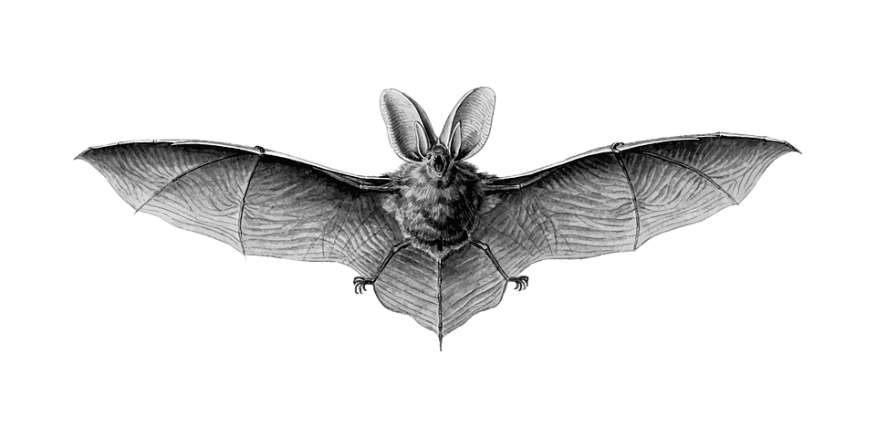
NORTH BUCKS BAT GROUP WINTER TALKS 2021

January  28th 6 – 7:30pm | Nathusius’ Pipistrelle Migration and AudioMoths on the South Coast  Using acoustic methods to study bat migration is a novel and controversial approach.  The prize is to paint a broad-brush picture of the flows of migrating bats around our coasts.  From a single detector on Chesil Beach to 25 AudioMoths spanning The Channel, Adrian takes you on his personal voyage of discovery, explaining how he approached the challenge and sharing his initial findings - plus a few surprises.  If anyone wants to delve deeper into AudioMoth issues, Adrain can stay on at the end for any more technical discussions. | Adrian Bicker Dorset Bat Group
February  25th 6 – 7:30pm | Monitoring Bechstein’s bats: combined approaches using molecular and landscape ecology  The Bechstein’s bat is one of Britain’s most elusive mammals.  In this talk, Patrick will introduce the main challenges faced when it comes to monitoring woodland bats.  He will explain how the combination of molecular and landscape information on Bechstein’s bat can help monitor populations and better conserve the species in Britain. | Dr Patrick Wright Vincent Wildlife Trust
March 25th  6 - 7:00pm | Swarming: Sites and species  The sea caves at Winspit (old quarries, believed to have been worked until the 1950s) are one of the most important sites for bats in Dorset, and even, perhaps, on the south coast, and the Dorset Bat Group have been studying bats’ swarming activities there for nearly a decade.  Nick will look back over the results of these surveys, exploring what they can tell us about how the bats are using the site, what implications that has for what we mean by a swarming species and possible implications for the management of underground sites. | Nick Tomlinson, Dorset Bat Group
April 21st  6 – 7:00pm | National Bats in Churches and Church Bat Detectives Project  Rose Riddell and Claire Boothby talk about how the Bats in Churches project is helping churches find ways to coexist with bats. There are hundreds of churches with bat roosts out there waiting to be discovered …. this talk will explain how you can get involved. | Claire Boothby and Rose Riddell, BCT

